OSLAB
Program 1: One Process (Before fork())
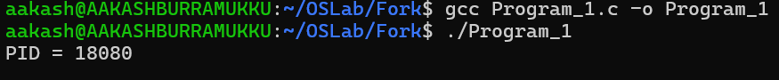
Program 2: fork() Creates a Child
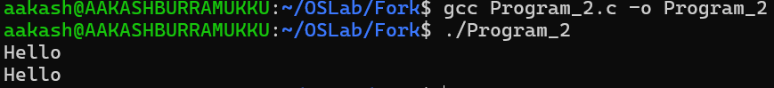
Program 3: Parent vs Child
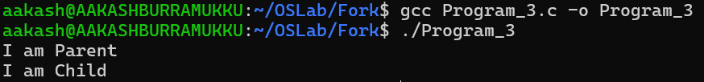
Program 4: Display Both PIDs
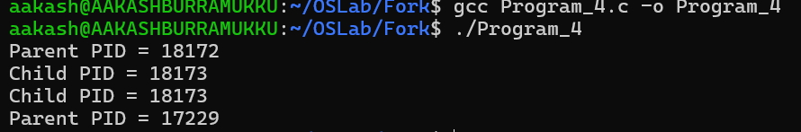
Program 5: Parent Waits for Child
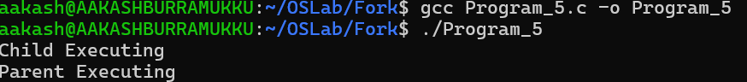
Program 6: Multiple fork() Calls
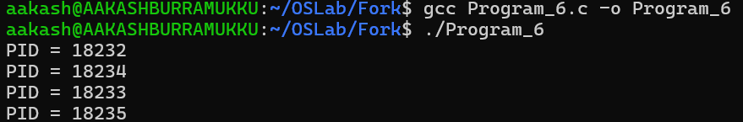

Program 7: Child Executes Another Program (exec())
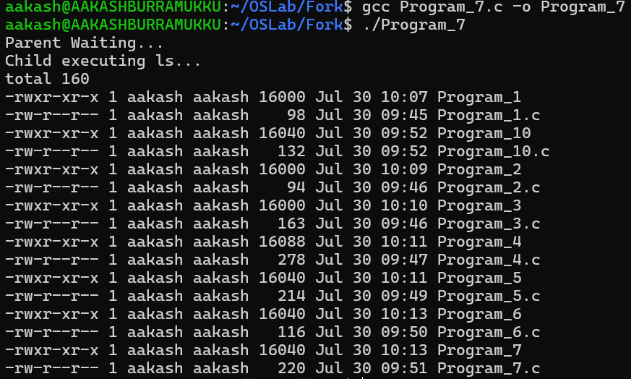
Program 10: fork() Inside a Loop (Fun)
